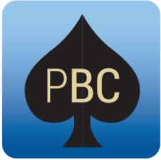PENINSULA  **BRIDGE CLUB**

Nelson Heather Centre,   
4 Jacksons Rd,   
Warriewood NSW 2102

**10am-5pm Sunday 15 July 2018**

Representing Peninsula in the

**Sydney North Interclub Pairs**

More info about the event - <http://bit.ly/2018SydNthPairs>

*Conducted under the auspices of the NSW Bridge Association. The Australian Bridge Federation has approved the issue of red masterpoints at level B5i.*

Event Details

* Last year Peninsula won the interclub pairs by half a point – can we win it again?
* One fun day, two sessions, two fields, six categories to ensure everyone can contribute to the club’s chances, red masterpoints
* We want our best pairs from rookies up
* Members are encouraged to bring a plate to share
* Entry fee - $25 per person – includes light lunch, and member provided finger food, and wine, juice and cheese at the end of play
* Director – John McIlrath

Prizes

* None – just play for the fun and the glory
* Be part of a winning fun team

How to enter

* Entry is initially by invitation to pairs who have done well over the last year
* We will then look at those who express their interest below

Inquiries?

* Inquiries to the Convener – Cassandra Mitchell, cassandra.  
  l.mitchell@gmail.com or 0421 764 300